Chapter 13
Return, Risk, and the Security Market Line

Multiple Choice Questions
1. You own a stock that you think will produce a return of 11 percent in a good economy and 3 percent in a poor economy. Given the probabilities of each state of the economy occurring, you anticipate that your stock will earn 6.5 percent next year. Which one of the following terms applies to this 6.5 percent?
A. arithmetic return
B. historical return
C. expected return
D. geometric return
E. required return

2. Suzie owns five different bonds valued at $36,000 and twelve different stocks valued at $82,500 total. Which one of the following terms most applies to Suzie's investments?
A. index
B. portfolio
C. collection
D. grouping
E. risk-free

3. Steve has invested in twelve different stocks that have a combined value today of $121,300. Fifteen percent of that total is invested in Wise Man Foods. The 15 percent is a measure of which one of the following?
A. portfolio return
B. portfolio weight
C. degree of risk
D. price-earnings ratio
E. index value

4. Which one of the following is a risk that applies to most securities?
A. unsystematic
B. diversifiable
C. systematic
D. asset-specific
E. total

5. A news flash just appeared that caused about a dozen stocks to suddenly drop in value by about 20 percent. What type of risk does this news flash represent?
A. portfolio
B. nondiversifiable
C. market
D. unsystematic
E. total

6. The principle of diversification tells us that:
A. concentrating an investment in two or three large stocks will eliminate all of the unsystematic risk.
B. concentrating an investment in three companies all within the same industry will greatly reduce the systematic risk.
C. spreading an investment across five diverse companies will not lower the total risk.
D. spreading an investment across many diverse assets will eliminate all of the systematic risk.
E. spreading an investment across many diverse assets will eliminate some of the total risk.

7. The _____ tells us that the expected return on a risky asset depends only on that asset's nondiversifiable risk.
A. efficient markets hypothesis
B. systematic risk principle
C. open markets theorem
D. law of one price
E. principle of diversification

8. Which one of the following measures the amount of systematic risk present in a particular risky asset relative to the systematic risk present in an average risky asset?
A. beta
B. reward-to-risk ratio
C. risk ratio
D. standard deviation
E. price-earnings ratio

9. Which one of the following is a positively sloped linear function that is created when expected returns are graphed against security betas?
A. reward-to-risk matrix
B. portfolio weight graph
C. normal distribution
D. security market line
E. market real returns

10. Which one of the following is represented by the slope of the security market line?
A. reward-to-risk ratio
B. market standard deviation
C. beta coefficient
D. risk-free interest rate
E. market risk premium

11. Which one of the following is the formula that explains the relationship between the expected return on a security and the level of that security's systematic risk?
A. capital asset pricing model
B. time value of money equation
C. unsystematic risk equation
D. market performance equation
E. expected risk formula

12. Treynor Industries is investing in a new project. The minimum rate of return the firm requires on this project is referred to as the:
A. average arithmetic return.
B. expected return.
C. market rate of return.
D. internal rate of return.
E. cost of capital.

13. The expected return on a stock given various states of the economy is equal to the:
A. highest expected return given any economic state.
B. arithmetic average of the returns for each economic state.
C. summation of the individual expected rates of return.
D. weighted average of the returns for each economic state.
E. return for the economic state with the highest probability of occurrence.

14. The expected return on a stock computed using economic probabilities is:
A. guaranteed to equal the actual average return on the stock for the next five years.
B. guaranteed to be the minimal rate of return on the stock over the next two years.
C. guaranteed to equal the actual return for the immediate twelve month period.
D. a mathematical expectation based on a weighted average and not an actual anticipated outcome.
E. the actual return you should anticipate as long as the economic forecast remains constant.

15. The expected risk premium on a stock is equal to the expected return on the stock minus the:
A. expected market rate of return.
B. risk-free rate.
C. inflation rate.
D. standard deviation.
E. variance.

16. Standard deviation measures which type of risk?
A. total
B. nondiversifiable
C. unsystematic
D. systematic
E. economic

17. The expected rate of return on a stock portfolio is a weighted average where the weights are based on the:
A. number of shares owned of each stock.
B. market price per share of each stock.
C. market value of the investment in each stock.
D. original amount invested in each stock.
E. cost per share of each stock held.

18. The expected return on a portfolio considers which of the following factors?
I. percentage of the portfolio invested in each individual security
II. projected states of the economy
III. the performance of each security given various economic states
IV. probability of occurrence for each state of the economy
A. I and III only
B. II and IV only
C. I, III, and IV only
D. II, III, and IV only
E. I, II, III, and IV

19. The expected return on a portfolio:
I. can never exceed the expected return of the best performing security in the portfolio.
II. must be equal to or greater than the expected return of the worst performing security in the portfolio.
III. is independent of the unsystematic risks of the individual securities held in the portfolio.
IV. is independent of the allocation of the portfolio amongst individual securities.
A. I and III only
B. II and IV only
C. I and II only
D. I, II, and III only
E. I, II, III, and IV

20. If a stock portfolio is well diversified, then the portfolio variance:
A. will equal the variance of the most volatile stock in the portfolio.
B. may be less than the variance of the least risky stock in the portfolio.
C. must be equal to or greater than the variance of the least risky stock in the portfolio.
D. will be a weighted average of the variances of the individual securities in the portfolio.
E. will be an arithmetic average of the variances of the individual securities in the portfolio.

21. The standard deviation of a portfolio:
A. is a weighted average of the standard deviations of the individual securities held in the portfolio.
B. can never be less than the standard deviation of the most risky security in the portfolio.
C. must be equal to or greater than the lowest standard deviation of any single security held in the portfolio.
D. is an arithmetic average of the standard deviations of the individual securities which comprise the portfolio.
E. can be less than the standard deviation of the least risky security in the portfolio.

22. The standard deviation of a portfolio:
A. is a measure of that portfolio's systematic risk.
B. is a weighed average of the standard deviations of the individual securities held in that portfolio.
C. measures the amount of diversifiable risk inherent in the portfolio.
D. serves as the basis for computing the appropriate risk premium for that portfolio.
E. can be less than the weighted average of the standard deviations of the individual securities held in that portfolio.

23. Which one of the following statements is correct concerning a portfolio of 20 securities with multiple states of the economy when both the securities and the economic states have unequal weights?
A. Given the unequal weights of both the securities and the economic states, the standard deviation of the portfolio must equal that of the overall market.
B. The weights of the individual securities have no effect on the expected return of a portfolio when multiple states of the economy are involved.
C. Changing the probabilities of occurrence for the various economic states will not affect the expected standard deviation of the portfolio.
D. The standard deviation of the portfolio will be greater than the highest standard deviation of any single security in the portfolio given that the individual securities are well diversified.
E. Given both the unequal weights of the securities and the economic states, an investor might be able to create a portfolio that has an expected standard deviation of zero.

24. Which one of the following events would be included in the expected return on Sussex stock?
A. The chief financial officer of Sussex unexpectedly resigned.
B. The labor union representing Sussex' employees unexpectedly called a strike.
C. This morning, Sussex confirmed that its CEO is retiring at the end of the year as was anticipated.
D. The price of Sussex stock suddenly declined in value because researchers accidentally discovered that one of the firm's products can be toxic to household pets.
E. The board of directors made an unprecedented decision to give sizeable bonuses to the firm's internal auditors for their efforts in uncovering wasteful spending.

25. Which one of the following statements is correct?
A. The unexpected return is always negative.
B. The expected return minus the unexpected return is equal to the total return.
C. Over time, the average return is equal to the unexpected return.
D. The expected return includes the surprise portion of news announcements.
E. Over time, the average unexpected return will be zero.

26. Which one of the following statements related to unexpected returns is correct?
A. All announcements by a firm affect that firm's unexpected returns.
B. Unexpected returns over time have a negative effect on the total return of a firm.
C. Unexpected returns are relatively predictable in the short-term.
D. Unexpected returns generally cause the actual return to vary significantly from the expected return over the long-term.
E. Unexpected returns can be either positive or negative in the short term but tend to be zero over the long-term.

27. Which one of the following is an example of systematic risk?
A. investors panic causing security prices around the globe to fall precipitously
B. a flood washes away a firm's warehouse
C. a city imposes an additional one percent sales tax on all products
D. a toymaker has to recall its top-selling toy
E. corn prices increase due to increased demand for alternative fuels

28. Unsystematic risk:
A. can be effectively eliminated by portfolio diversification.
B. is compensated for by the risk premium.
C. is measured by beta.
D. is measured by standard deviation.
E. is related to the overall economy.

29. Which one of the following is an example of unsystematic risk?
A. income taxes are increased across the board
B. a national sales tax is adopted
C. inflation decreases at the national level
D. an increased feeling of prosperity is felt around the globe
E. consumer spending on entertainment decreased nationally

30. Which one of the following is least apt to reduce the unsystematic risk of a portfolio?
A. reducing the number of stocks held in the portfolio
B. adding bonds to a stock portfolio
C. adding international securities into a portfolio of U.S. stocks
D. adding U.S. Treasury bills to a risky portfolio
E. adding technology stocks to a portfolio of industrial stocks

31. Which one of the following statements is correct concerning unsystematic risk?
A. An investor is rewarded for assuming unsystematic risk.
B. Eliminating unsystematic risk is the responsibility of the individual investor.
C. Unsystematic risk is rewarded when it exceeds the market level of unsystematic risk.
D. Beta measures the level of unsystematic risk inherent in an individual security.
E. Standard deviation is a measure of unsystematic risk.

32. Which one of the following statements related to risk is correct?
A. The beta of a portfolio must increase when a stock with a high standard deviation is added to the portfolio.
B. Every portfolio that contains 25 or more securities is free of unsystematic risk.
C. The systematic risk of a portfolio can be effectively lowered by adding T-bills to the portfolio.
D. Adding five additional stocks to a diversified portfolio will lower the portfolio's beta.
E. Stocks that move in tandem with the overall market have zero betas.

33. Which one of the following risks is irrelevant to a well-diversified investor?
A. systematic risk
B. unsystematic risk
C. market risk
D. nondiversifiable risk
E. systematic portion of a surprise

34. Which of the following are examples of diversifiable risk?
I. earthquake damages an entire town
II. federal government imposes a $100 fee on all business entities
III. employment taxes increase nationally
IV. toymakers are required to improve their safety standards
A. I and III only
B. II and IV only
C. II and III only
D. I and IV only
E. I, III, and IV only

35. Which of the following statements are correct concerning diversifiable risks?
I. Diversifiable risks can be essentially eliminated by investing in thirty unrelated securities.
II. There is no reward for accepting diversifiable risks.
III. Diversifiable risks are generally associated with an individual firm or industry.
IV. Beta measures diversifiable risk.
A. I and III only
B. II and IV only
C. I and IV only
D. I, II and III only
E. I, II, III, and IV

36. Which one of the following is the best example of a diversifiable risk?
A. interest rates increase
B. energy costs increase
C. core inflation increases
D. a firm's sales decrease
E. taxes decrease

37. Which of the following statements concerning risk are correct?
I. Nondiversifiable risk is measured by beta.
II. The risk premium increases as diversifiable risk increases.
III. Systematic risk is another name for nondiversifiable risk.
IV. Diversifiable risks are market risks you cannot avoid.
A. I and III only
B. II and IV only
C. I and II only
D. III and IV only
E. I, II, and III only

38. The primary purpose of portfolio diversification is to:
A. increase returns and risks.
B. eliminate all risks.
C. eliminate asset-specific risk.
D. eliminate systematic risk.
E. lower both returns and risks.

39. Which one of the following indicates a portfolio is being effectively diversified?
A. an increase in the portfolio beta
B. a decrease in the portfolio beta
C. an increase in the portfolio rate of return
D. an increase in the portfolio standard deviation
E. a decrease in the portfolio standard deviation

40. How many diverse securities are required to eliminate the majority of the diversifiable risk from a portfolio?
A. 5
B. 10
C. 25
D. 50
E. 75

41. Systematic risk is measured by:
A. the mean.
B. beta.
C. the geometric average.
D. the standard deviation.
E. the arithmetic average.

42. Which one of the following is most directly affected by the level of systematic risk in a security?
A. variance of the returns
B. standard deviation of the returns
C. expected rate of return
D. risk-free rate
E. market risk premium

43. Which one of the following statements is correct concerning a portfolio beta?
A. Portfolio betas range between -1.0 and +1.0.
B. A portfolio beta is a weighted average of the betas of the individual securities contained in the portfolio.
C. A portfolio beta cannot be computed from the betas of the individual securities comprising the portfolio because some risk is eliminated via diversification.
D. A portfolio of U.S. Treasury bills will have a beta of +1.0.
E. The beta of a market portfolio is equal to zero.

44. The systematic risk of the market is measured by:
A. a beta of 1.0.
B. a beta of 0.0.
C. a standard deviation of 1.0.
D. a standard deviation of 0.0.
E. a variance of 1.0.

45. At a minimum, which of the following would you need to know to estimate the amount of additional reward you will receive for purchasing a risky asset instead of a risk-free asset?
I. asset's standard deviation
II. asset's beta
III. risk-free rate of return
IV. market risk premium
A. I and III only
B. II and IV only
C. III and IV only
D. I, III, and IV only
E. I, II, III, and IV

46. Total risk is measured by _____ and systematic risk is measured by _____.
A. beta; alpha
B. beta; standard deviation
C. alpha; beta
D. standard deviation; beta
E. standard deviation; variance

47. The intercept point of the security market line is the rate of return which corresponds to:
A. the risk-free rate.
B. the market rate.
C. a return of zero.
D. a return of 1.0 percent.
E. the market risk premium.

48. A stock with an actual return that lies above the security market line has:
A. more systematic risk than the overall market.
B. more risk than that warranted by CAPM.
C. a higher return than expected for the level of risk assumed.
D. less systematic risk than the overall market.
E. a return equivalent to the level of risk assumed.

49. The market rate of return is 11 percent and the risk-free rate of return is 3 percent. Lexant stock has 3 percent less systematic risk than the market and has an actual return of 12 percent. This stock:
A. is underpriced.
B. is correctly priced.
C. will plot below the security market line.
D. will plot on the security market line.
E. will plot to the right of the overall market on a security market line graph.

50. Which one of the following will be constant for all securities if the market is efficient and securities are priced fairly?
A. variance
B. standard deviation
C. reward-to-risk ratio
D. beta
E. risk premium

51. The reward-to-risk ratio for stock A is less than the reward-to-risk ratio of stock B. Stock A has a beta of 0.82 and stock B has a beta of 1.29. This information implies that:
A. stock A is riskier than stock B and both stocks are fairly priced.
B. stock A is less risky than stock B and both stocks are fairly priced.
C. either stock A is underpriced or stock B is overpriced or both.
D. either stock A is overpriced or stock B is underpriced or both.
E. both stock A and stock B are correctly priced since stock A is riskier than stock B.

52. The market risk premium is computed by:
A. adding the risk-free rate of return to the inflation rate.
B. adding the risk-free rate of return to the market rate of return.
C. subtracting the risk-free rate of return from the inflation rate.
D. subtracting the risk-free rate of return from the market rate of return.
E. multiplying the risk-free rate of return by a beta of 1.0.

53. The excess return earned by an asset that has a beta of 1.34 over that earned by a risk-free asset is referred to as the:
A. market risk premium.
B. risk premium.
C. systematic return.
D. total return.
E. real rate of return.

54. The _____ of a security divided by the beta of that security is equal to the slope of the security market line if the security is priced fairly.
A. real return
B. actual return
C. nominal return
D. risk premium
E. expected return

55. The capital asset pricing model (CAPM) assumes which of the following?
I. a risk-free asset has no systematic risk.
II. beta is a reliable estimate of total risk.
III. the reward-to-risk ratio is constant.
IV. the market rate of return can be approximated.
A. I and III only
B. II and IV only
C. I, III, and IV only
D. II, III, and IV only
E. I, II, III, and IV

56. According to CAPM, the amount of reward an investor receives for bearing the risk of an individual security depends upon the:
A. amount of total risk assumed and the market risk premium.
B. market risk premium and the amount of systematic risk inherent in the security.
C. risk free rate, the market rate of return, and the standard deviation of the security.
D. beta of the security and the market rate of return.
E. standard deviation of the security and the risk-free rate of return.

57. Which one of the following should earn the most risk premium based on CAPM?
A. diversified portfolio with returns similar to the overall market
B. stock with a beta of 1.38
C. stock with a beta of 0.74
D. U.S. Treasury bill
E. portfolio with a beta of 1.01

58. You want your portfolio beta to be 0.95. Currently, your portfolio consists of $4,000 invested in stock A with a beta of 1.47 and $3,000 in stock B with a beta of 0.54. You have another $9,000 to invest and want to divide it between an asset with a beta of 1.74 and a risk-free asset. How much should you invest in the risk-free asset?
A. $4,316.08
B. $4,425.29
C. $4,902.29
D. $4,574.71
E. $4,683.92

59. You have a $12,000 portfolio which is invested in stocks A and B, and a risk-free asset. $5,000 is invested in stock A. Stock A has a beta of 1.76 and stock B has a beta of 0.89. How much needs to be invested in stock B if you want a portfolio beta of 1.10?
A. $3,750.00
B. $4,333.33
C. $4,706.20
D. $4,943.82
E. $5,419.27

60. You recently purchased a stock that is expected to earn 22 percent in a booming economy, 9 percent in a normal economy, and lose 33 percent in a recessionary economy. There is a 5 percent probability of a boom and a 75 percent chance of a normal economy. What is your expected rate of return on this stock?
A. -3.40 percent
B. -2.25 percent
C. 1.25 percent
D. 2.60 percent
E. 3.50 percent

61. The common stock of Manchester & Moore is expected to earn 13 percent in a recession, 6 percent in a normal economy, and lose 4 percent in a booming economy. The probability of a boom is 5 percent while the probability of a recession is 45 percent. What is the expected rate of return on this stock?
A. 8.52 percent
B. 8.74 percent
C. 8.65 percent
D. 9.05 percent
E. 9.28 percent

62. You are comparing stock A to stock B. Given the following information, what is the difference in the expected returns of these two securities?
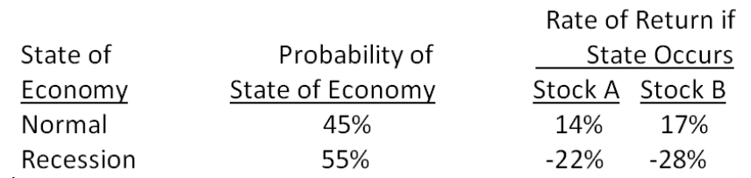
A. -0.85 percent
B. 1.95 percent
C. 2.05 percent
D. 13.45 percent
E. 13.55 percent

63. Jerilu Markets has a beta of 1.09. The risk-free rate of return is 2.75 percent and the market rate of return is 9.80 percent. What is the risk premium on this stock?
A. 6.47 percent
B. 7.03 percent
C. 7.68 percent
D. 8.99 percent
E. 9.80 percent

64. If the economy is normal, Charleston Freight stock is expected to return 15.7 percent. If the economy falls into a recession, the stock's return is projected at a negative 11.6 percent. The probability of a normal economy is 80 percent while the probability of a recession is 20 percent. What is the variance of the returns on this stock?
A. 0.010346
B. 0.011925
C. 0.013420
D. 0.013927
E. 0.014315

65. The rate of return on the common stock of Lancaster Woolens is expected to be 21 percent in a boom economy, 11 percent in a normal economy, and only 3 percent in a recessionary economy. The probabilities of these economic states are 10 percent for a boom, 70 percent for a normal economy, and 20 percent for a recession. What is the variance of the returns on this common stock?
A. 0.002150
B. 0.002606
C. 0.002244
D. 0.002359
E. 0.002421

66. The returns on the common stock of New Image Products are quite cyclical. In a boom economy, the stock is expected to return 32 percent in comparison to 14 percent in a normal economy and a negative 28 percent in a recessionary period. The probability of a recession is 25 percent while the probability of a boom is 10 percent. What is the standard deviation of the returns on this stock?
A. 19.94 percent
B. 21.56 percent
C. 25.83 percent
D. 32.08 percent
E. 39.77 percent

67. What is the standard deviation of the returns on a stock given the following information?
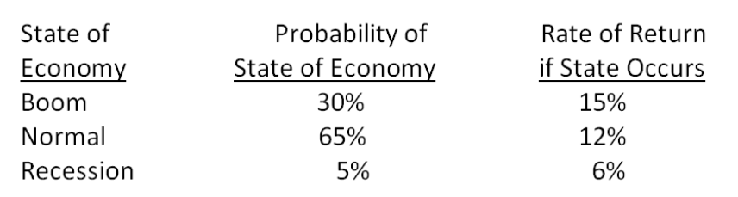
A. 1.57 percent
B. 2.03 percent
C. 2.89 percent
D. 3.42 percent
E. 4.01 percent

68. You have a portfolio consisting solely of stock A and stock B. The portfolio has an expected return of 8.7 percent. Stock A has an expected return of 11.4 percent while stock B is expected to return 6.4 percent. What is the portfolio weight of stock A?
A. 39 percent
B. 46 percent
C. 54 percent
D. 61 percent
E. 67 percent

69. You own the following portfolio of stocks. What is the portfolio weight of stock C?
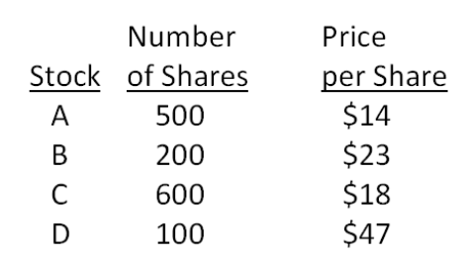
A. 39.85 percent
B. 42.86 percent
C. 44.41 percent
D. 48.09 percent
E. 52.65 percent

70. You own a portfolio with the following expected returns given the various states of the economy. What is the overall portfolio expected return?
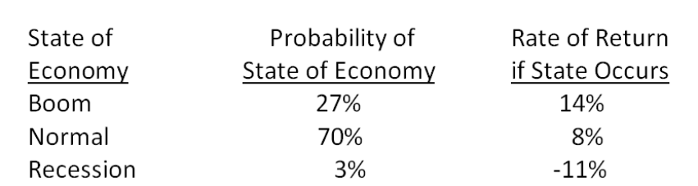
A. 6.49 percent
B. 8.64 percent
C. 8.87 percent
D. 9.05 percent
E. 9.23 percent

71. What is the expected return on a portfolio which is invested 25 percent in stock A, 55 percent in stock B, and the remainder in stock C?
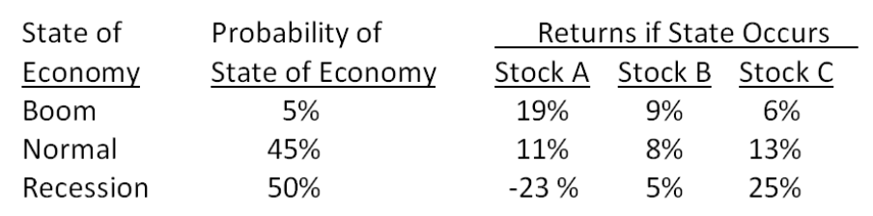
A. -1.06 percent
B. 2.38 percent
C. 2.99 percent
D. 5.93 percent
E. 6.10 percent

72. What is the expected return on this portfolio?
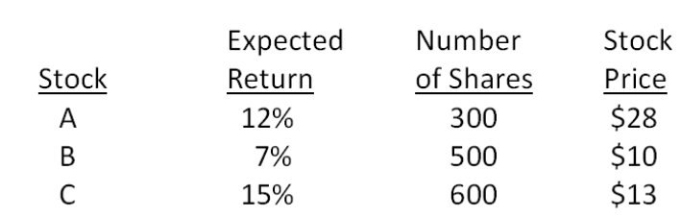
A. 11.48 percent
B. 11.92 percent
C. 13.03 percent
D. 13.42 percent
E. 13.97 percent

73. What is the expected return on a portfolio that is equally weighted between stocks K and L given the following information?
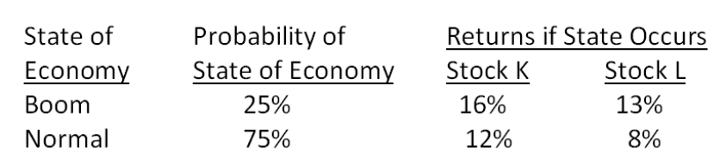
A. 11.13 percent
B. 11.86 percent
C. 12.25 percent
D. 13.32 percent
E. 14.40 percent

74. What is the expected return on a portfolio comprised of $6,200 of stock M and $4,500 of stock N if the economy enjoys a boom period?
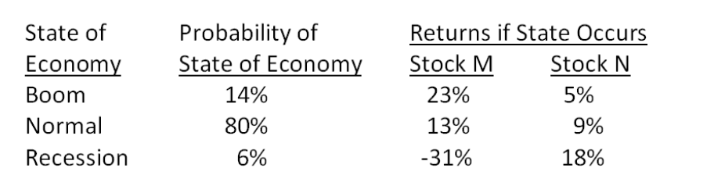
A. 10.93 percent
B. 11.16 percent
C. 12.55 percent
D. 13.78 percent
E. 15.43 percent

75. What is the variance of the returns on a portfolio that is invested 60 percent in stock S and 40 percent in stock T?
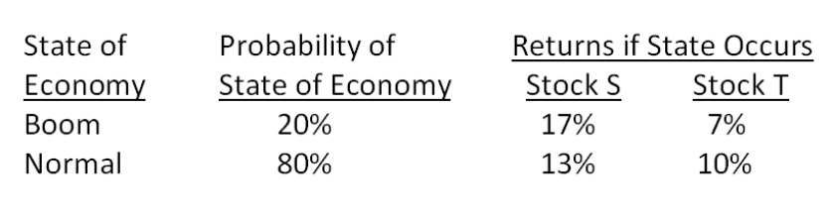
A. .000017
B. .000023
C. .000118
D. .000136
E. .000161

76. What is the variance of the returns on a portfolio comprised of $5,400 of stock G and $6,600 of stock H?
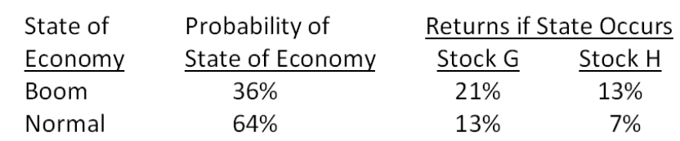
A. .000709
B. .000848
C. .001097
D. .001254
E. .001468

77. What is the standard deviation of the returns on a portfolio that is invested 52 percent in stock Q and 48 percent in stock R?
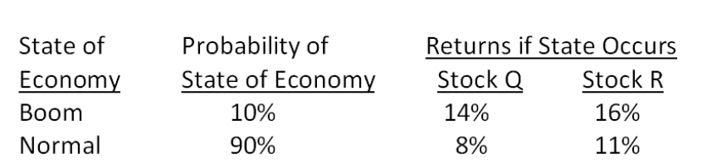
A. 1.66 percent
B. 2.47 percent
C. 2.63 percent
D. 3.28 percent
E. 3.41 percent

78. What is the standard deviation of the returns on a $30,000 portfolio which consists of stocks S and T? Stock S is valued at $12,000.
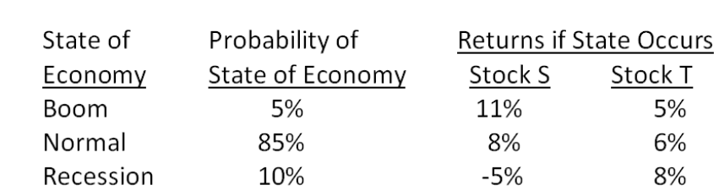
A. 1.07 percent
B. 1.22 percent
C. 1.36 percent
D. 1.49 percent
E. 1.63 percent

79. What is the standard deviation of the returns on a portfolio that is invested in stocks A, B, and C? Twenty five percent of the portfolio is invested in stock A and 40 percent is invested in stock C.
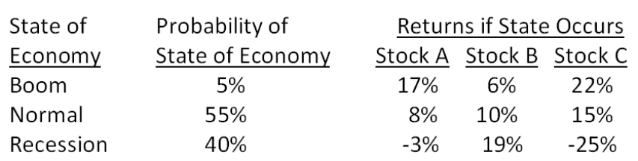
A. 6.31 percent
B. 6.49 percent
C. 7.40 percent
D. 7.83 percent
E. 8.72 percent

80. What is the beta of the following portfolio?
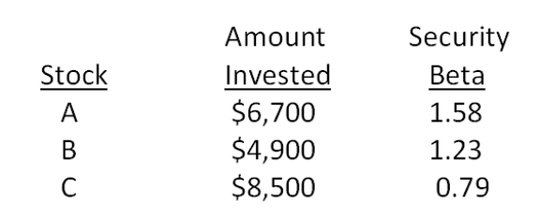
A. 1.04
B. 1.07
C. 1.13
D. 1.16
E. 1.23

81. Your portfolio is comprised of 40 percent of stock X, 15 percent of stock Y, and 45 percent of stock Z. Stock X has a beta of 1.16, stock Y has a beta of 1.47, and stock Z has a beta of 0.42. What is the beta of your portfolio?
A. 0.87
B. 1.09
C. 1.13
D. 1.18
E. 1.21

82. Your portfolio has a beta of 1.12. The portfolio consists of 20 percent U.S. Treasury bills, 50 percent stock A, and 30 percent stock B. Stock A has a risk-level equivalent to that of the overall market. What is the beta of stock B?
A. 1.47
B. 1.52
C. 1.69
D. 1.84
E. 2.07

83. You would like to combine a risky stock with a beta of 1.68 with U.S. Treasury bills in such a way that the risk level of the portfolio is equivalent to the risk level of the overall market. What percentage of the portfolio should be invested in the risky stock?
A. 32 percent
B. 40 percent
C. 54 percent
D. 60 percent
E. 68 percent

84. The market has an expected rate of return of 10.7 percent. The long-term government bond is expected to yield 5.8 percent and the U.S. Treasury bill is expected to yield 3.9 percent. The inflation rate is 3.6 percent. What is the market risk premium?
A. 6.0 percent
B. 6.8 percent
C. 7.5 percent
D. 8.5 percent
E. 9.3 percent

85. The risk-free rate of return is 3.9 percent and the market risk premium is 6.2 percent. What is the expected rate of return on a stock with a beta of 1.21?
A. 10.92 percent
B. 11.40 percent
C. 12.22 percent
D. 12.47 percent
E. 12.79 percent

86. The common stock of Jensen Shipping has an expected return of 16.3 percent. The return on the market is 10.8 percent and the risk-free rate of return is 3.8 percent. What is the beta of this stock?
A. .92
B. 1.23
C. 1.33
D. 1.67
E. 1.79

87. The common stock of United Industries has a beta of 1.34 and an expected return of 14.29 percent. The risk-free rate of return is 3.7 percent. What is the expected market risk premium?
A. 7.02 percent
B. 7.90 percent
C. 10.63 percent
D. 11.22 percent
E. 11.60 percent

88. The expected return on JK stock is 15.78 percent while the expected return on the market is 11.34 percent. The stock's beta is 1.62. What is the risk-free rate of return?
A. 3.22 percent
B. 3.59 percent
C. 3.63 percent
D. 3.79 percent
E. 4.18 percent

89. Thayer Farms stock has a beta of 1.12. The risk-free rate of return is 4.34 percent and the market risk premium is 7.92 percent. What is the expected rate of return on this stock?
A. 8.35 percent
B. 9.01 percent
C. 10.23 percent
D. 13.21 percent
E. 13.73 percent

90. The common stock of Alpha Manufacturers has a beta of 1.47 and an actual expected return of 15.26 percent. The risk-free rate of return is 4.3 percent and the market rate of return is 12.01 percent. Which one of the following statements is true given this information?
A. The actual expected stock return will graph above the Security Market Line.
B. The stock is underpriced.
C. To be correctly priced according to CAPM, the stock should have an expected return of 21.95 percent.
D. The stock has less systematic risk than the overall market.
E. The actual expected stock return indicates the stock is currently overpriced.

91. Which one of the following stocks is correctly priced if the risk-free rate of return is 3.7 percent and the market risk premium is 8.8 percent?
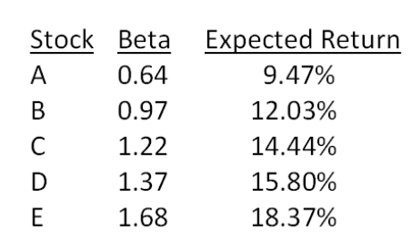
A. A
B. B
C. C
D. D
E. E

92. Which one of the following stocks is correctly priced if the risk-free rate of return is 3.2 percent and the market rate of return is 11.76 percent?
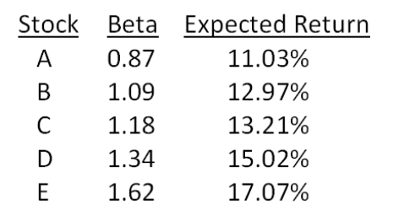
A. A
B. B
C. C
D. D
E. E

Essay Questions
93. According to CAPM, the expected return on a risky asset depends on three components.
Describe each component and explain its role in determining expected return.

94. Explain how the slope of the security market line is determined and why every stock that is correctly priced, according to CAPM, will lie on this line.

95. Explain how the beta of a portfolio can equal the market beta if 50 percent of the portfolio is invested in a security that has twice the amount of systematic risk as an average risky security.

96. Explain the difference between systematic and unsystematic risk. Also explain why one of these types of risks is rewarded with a risk premium while the other type is not.

97. A portfolio beta is a weighted average of the betas of the individual securities which comprise the portfolio. However, the standard deviation is not a weighted average of the standard deviations of the individual securities which comprise the portfolio. Explain why this difference exists.

Multiple Choice Questions
98. You own a portfolio that has $2,000 invested in Stock A and $1,400 invested in Stock B. The expected returns on these stocks are 14 percent and 9 percent, respectively. What is the expected return on the portfolio?
A. 11.06 percent
B. 11.50 percent
C. 11.94 percent
D. 12.13 percent
E. 12.41 percent

99. You have $10,000 to invest in a stock portfolio. Your choices are Stock X with an expected return of 13 percent and Stock Y with an expected return of 8 percent. Your goal is to create a portfolio with an expected return of 12.4 percent. All money must be invested. How much will you invest in stock X?
A. $800
B. $1,200
C. $4,600
D. $8,800
E. $9,200

100. What is the expected return and standard deviation for the following stock?
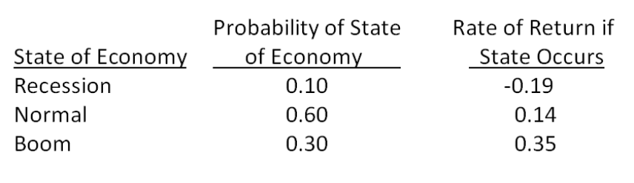
A. 15.49 percent; 14.28 percent
B. 15.49 percent; 14.67 percent
C. 17.00 percent; 15.24 percent
D. 17.00 percent; 15.74 percent
E. 17.00 percent'; 16.01 percent

101. What is the expected return of an equally weighted portfolio comprised of the following three stocks?
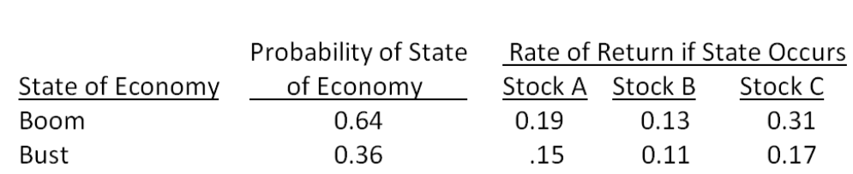
A. 16.33 percent
B. 18.60 percent
C. 19.67 percent
D. 20.48 percent
E. 21.33 percent

102. Your portfolio is invested 26 percent each in Stocks A and C, and 48 percent in Stock B. What is the standard deviation of your portfolio given the following information?
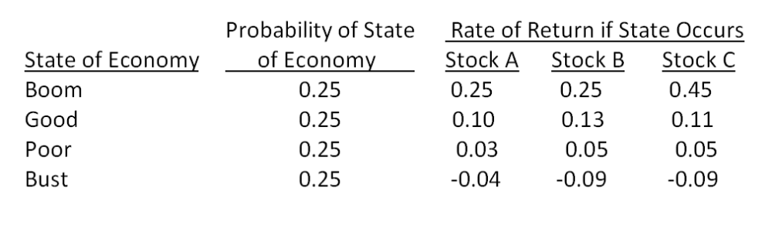
A. 12.38 percent
B. 12.64 percent
C. 12.72 percent
D. 12.89 percent
E. 13.73 percent

103. You own a portfolio equally invested in a risk-free asset and two stocks. One of the stocks has a beta of 1.9 and the total portfolio is equally as risky as the market. What is the beta of the second stock?
A. 0.75
B. 0.80
C. 0.94
D. 1.00
E. 1.10

104. A stock has an expected return of 11 percent, the risk-free rate is 6.1 percent, and the market risk premium is 4 percent. What is the stock's beta?
A. 1.18
B. 1.23
C. 1.29
D. 1.32
E. 1.35

105. A stock has a beta of 1.2 and an expected return of 17 percent. A risk-free asset currently earns 5.1 percent. The beta of a portfolio comprised of these two assets is 0.85. What percentage of the portfolio is invested in the stock?
A. 71 percent
B. 77 percent
C. 84 percent
D. 89 percent
E. 92 percent

106. Consider the following information on three stocks:
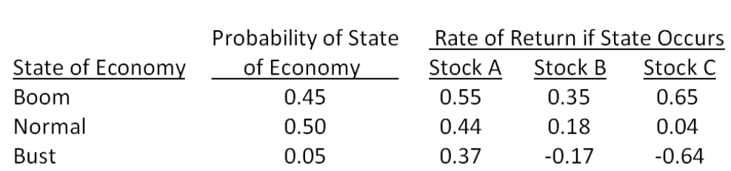
A portfolio is invested 35 percent each in Stock A and Stock B and 30 percent in Stock C. What is the expected risk premium on the portfolio if the expected T-bill rate is 3.8 percent?
A. 11.47 percent
B. 12.38 percent
C. 16.67 percent
D. 24.29 percent
E. 29.99 percent

107. Suppose you observe the following situation:
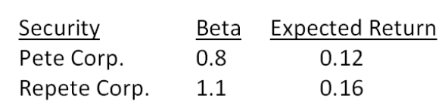
Assume these securities are correctly priced. Based on the CAPM, what is the return on the market?
A. 13.99 percent
B. 14.42 percent
C. 14.67 percent
D. 14.78 percent
E. 15.01 percent

108. Consider the following information on Stocks I and II:
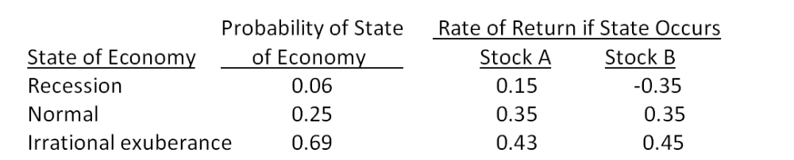
The market risk premium is 8 percent, and the risk-free rate is 3.6 percent. The beta of stock I is _____ and the beta of stock II is _____.
A. 2.08; 2.47
B. 2.08; 2.76
C. 3.21; 3.84
D. 4.47; 3.89
E. 4.47; 4.26

109. Suppose you observe the following situation:
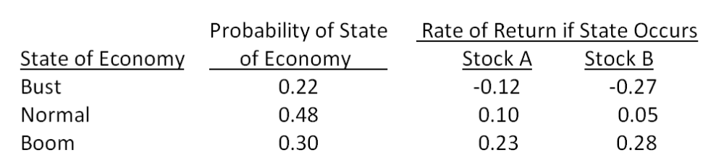
Assume the capital asset pricing model holds and stock A's beta is greater than stock B's beta by 0.21. What is the expected market risk premium?
A. 8.8 percent
B. 9.5 percent
C. 12.6 percent
D. 17.9 percent
E. 20.0 percent

Chapter 13 Return, Risk, and the Security Market Line Answer Key

Multiple Choice Questions
1. You own a stock that you think will produce a return of 11 percent in a good economy and 3 percent in a poor economy. Given the probabilities of each state of the economy occurring, you anticipate that your stock will earn 6.5 percent next year. Which one of the following terms applies to this 6.5 percent?
A. arithmetic return
B. historical return
C. expected return
D. geometric return
E. required return
Refer to section 13.1

AACSB: N/A
Bloom's: Knowledge
Difficulty: Basic
Learning Objective: 13-1
Section: 13.1
Topic: Expected return
2. Suzie owns five different bonds valued at $36,000 and twelve different stocks valued at $82,500 total. Which one of the following terms most applies to Suzie's investments?
A. index
B. portfolio
C. collection
D. grouping
E. risk-free
Refer to section 13.2

AACSB: N/A
Bloom's: Knowledge
Difficulty: Basic
Learning Objective: 13-2
Section: 13.2
Topic: Portfolio
3. Steve has invested in twelve different stocks that have a combined value today of $121,300. Fifteen percent of that total is invested in Wise Man Foods. The 15 percent is a measure of which one of the following?
A. portfolio return
B. portfolio weight
C. degree of risk
D. price-earnings ratio
E. index value
Refer to section 13.2

AACSB: N/A
Bloom's: Knowledge
Difficulty: Basic
Learning Objective: 13-2
Section: 13.2
Topic: Portfolio weight
4. Which one of the following is a risk that applies to most securities?
A. unsystematic
B. diversifiable
C. systematic
D. asset-specific
E. total
Refer to section 13.4

AACSB: N/A
Bloom's: Knowledge
Difficulty: Basic
Learning Objective: 13-3
Section: 13.4
Topic: Systematic risk
5. A news flash just appeared that caused about a dozen stocks to suddenly drop in value by about 20 percent. What type of risk does this news flash represent?
A. portfolio
B. nondiversifiable
C. market
D. unsystematic
E. total
Refer to section 13.4

AACSB: N/A
Bloom's: Comprehension
Difficulty: Basic
Learning Objective: 13-3
Section: 13.4
Topic: Unsystematic risk
6. The principle of diversification tells us that:
A. concentrating an investment in two or three large stocks will eliminate all of the unsystematic risk.
B. concentrating an investment in three companies all within the same industry will greatly reduce the systematic risk.
C. spreading an investment across five diverse companies will not lower the total risk.
D. spreading an investment across many diverse assets will eliminate all of the systematic risk.
E. spreading an investment across many diverse assets will eliminate some of the total risk.
Refer to section 13.5

AACSB: N/A
Bloom's: Knowledge
Difficulty: Basic
Learning Objective: 13-2
Section: 13.5
Topic: Diversification
7. The _____ tells us that the expected return on a risky asset depends only on that asset's nondiversifiable risk.
A. efficient markets hypothesis
B. systematic risk principle
C. open markets theorem
D. law of one price
E. principle of diversification
Refer to section 13.6

AACSB: N/A
Bloom's: Knowledge
Difficulty: Basic
Learning Objective: 13-3
Section: 13.6
Topic: Systematic risk
8. Which one of the following measures the amount of systematic risk present in a particular risky asset relative to the systematic risk present in an average risky asset?
A. beta
B. reward-to-risk ratio
C. risk ratio
D. standard deviation
E. price-earnings ratio
Refer to section 13.6

AACSB: N/A
Bloom's: Knowledge
Difficulty: Basic
Learning Objective: 13-3
Section: 13.6
Topic: Beta
9. Which one of the following is a positively sloped linear function that is created when expected returns are graphed against security betas?
A. reward-to-risk matrix
B. portfolio weight graph
C. normal distribution
D. security market line
E. market real returns
Refer to section 13.7

AACSB: N/A
Bloom's: Knowledge
Difficulty: Basic
Learning Objective: 13-4
Section: 13.7
Topic: Security market line
10. Which one of the following is represented by the slope of the security market line?
A. reward-to-risk ratio
B. market standard deviation
C. beta coefficient
D. risk-free interest rate
E. market risk premium
Refer to section 13.7

AACSB: N/A
Bloom's: Comprehension
Difficulty: Basic
Learning Objective: 13-4
Section: 13.7
Topic: Security market line
11. Which one of the following is the formula that explains the relationship between the expected return on a security and the level of that security's systematic risk?
A. capital asset pricing model
B. time value of money equation
C. unsystematic risk equation
D. market performance equation
E. expected risk formula
Refer to section 13.7

AACSB: N/A
Bloom's: Knowledge
Difficulty: Basic
Learning Objective: 13-4
Section: 13.7
Topic: Capital asset pricing model
12. Treynor Industries is investing in a new project. The minimum rate of return the firm requires on this project is referred to as the:
A. average arithmetic return.
B. expected return.
C. market rate of return.
D. internal rate of return.
E. cost of capital.
Refer to section 13.8

AACSB: N/A
Bloom's: Knowledge
Difficulty: Basic
Learning Objective: 13-4
Section: 13.8
Topic: Cost of capital
13. The expected return on a stock given various states of the economy is equal to the:
A. highest expected return given any economic state.
B. arithmetic average of the returns for each economic state.
C. summation of the individual expected rates of return.
D. weighted average of the returns for each economic state.
E. return for the economic state with the highest probability of occurrence.
Refer to section 13.1

AACSB: N/A
Bloom's: Knowledge
Difficulty: Basic
Learning Objective: 13-1
Section: 13.1
Topic: Expected return
14. The expected return on a stock computed using economic probabilities is:
A. guaranteed to equal the actual average return on the stock for the next five years.
B. guaranteed to be the minimal rate of return on the stock over the next two years.
C. guaranteed to equal the actual return for the immediate twelve month period.
D. a mathematical expectation based on a weighted average and not an actual anticipated outcome.
E. the actual return you should anticipate as long as the economic forecast remains constant.
Refer to section 13.1

AACSB: N/A
Bloom's: Comprehension
Difficulty: Basic
Learning Objective: 13-1
Section: 13.1
Topic: Expected return
15. The expected risk premium on a stock is equal to the expected return on the stock minus the:
A. expected market rate of return.
B. risk-free rate.
C. inflation rate.
D. standard deviation.
E. variance.
Refer to section 13.1

AACSB: N/A
Bloom's: Knowledge
Difficulty: Basic
Learning Objective: 13-1
Section: 13.1
Topic: Risk premium
16. Standard deviation measures which type of risk?
A. total
B. nondiversifiable
C. unsystematic
D. systematic
E. economic
Refer to section 13.1

AACSB: N/A
Bloom's: Knowledge
Difficulty: Basic
Learning Objective: 13-3
Section: 13.1
Topic: Standard deviation
17. The expected rate of return on a stock portfolio is a weighted average where the weights are based on the:
A. number of shares owned of each stock.
B. market price per share of each stock.
C. market value of the investment in each stock.
D. original amount invested in each stock.
E. cost per share of each stock held.
Refer to section 13.2

AACSB: N/A
Bloom's: Knowledge
Difficulty: Basic
Learning Objective: 13-1
Section: 13.2
Topic: Expected return
18. The expected return on a portfolio considers which of the following factors?
I. percentage of the portfolio invested in each individual security
II. projected states of the economy
III. the performance of each security given various economic states
IV. probability of occurrence for each state of the economy
A. I and III only
B. II and IV only
C. I, III, and IV only
D. II, III, and IV only
E. I, II, III, and IV
Refer to section 13.2

AACSB: N/A
Bloom's: Knowledge
Difficulty: Basic
Learning Objective: 13-1
Section: 13.2
Topic: Expected return
19. The expected return on a portfolio:
I. can never exceed the expected return of the best performing security in the portfolio.
II. must be equal to or greater than the expected return of the worst performing security in the portfolio.
III. is independent of the unsystematic risks of the individual securities held in the portfolio.
IV. is independent of the allocation of the portfolio amongst individual securities.
A. I and III only
B. II and IV only
C. I and II only
D. I, II, and III only
E. I, II, III, and IV
Refer to sections 13.2 and 13.6

AACSB: N/A
Bloom's: Comprehension
Difficulty: Intermediate
Learning Objective: 13-1
Section: 13.2 and 13.6
Topic: Expected return
20. If a stock portfolio is well diversified, then the portfolio variance:
A. will equal the variance of the most volatile stock in the portfolio.
B. may be less than the variance of the least risky stock in the portfolio.
C. must be equal to or greater than the variance of the least risky stock in the portfolio.
D. will be a weighted average of the variances of the individual securities in the portfolio.
E. will be an arithmetic average of the variances of the individual securities in the portfolio.
Refer to section 13.5

AACSB: N/A
Bloom's: Comprehension
Difficulty: Basic
Learning Objective: 13-2
Section: 13.5
Topic: Diversification
21. The standard deviation of a portfolio:
A. is a weighted average of the standard deviations of the individual securities held in the portfolio.
B. can never be less than the standard deviation of the most risky security in the portfolio.
C. must be equal to or greater than the lowest standard deviation of any single security held in the portfolio.
D. is an arithmetic average of the standard deviations of the individual securities which comprise the portfolio.
E. can be less than the standard deviation of the least risky security in the portfolio.
Refer to section 13.2

AACSB: N/A
Bloom's: Comprehension
Difficulty: Basic
Learning Objective: 13-1
Section: 13.2
Topic: Standard deviation
22. The standard deviation of a portfolio:
A. is a measure of that portfolio's systematic risk.
B. is a weighed average of the standard deviations of the individual securities held in that portfolio.
C. measures the amount of diversifiable risk inherent in the portfolio.
D. serves as the basis for computing the appropriate risk premium for that portfolio.
E. can be less than the weighted average of the standard deviations of the individual securities held in that portfolio.
Refer to section 13.5

AACSB: N/A
Bloom's: Comprehension
Difficulty: Intermediate
Learning Objective: 13-2
Section: 13.5
Topic: Standard deviation
23. Which one of the following statements is correct concerning a portfolio of 20 securities with multiple states of the economy when both the securities and the economic states have unequal weights?
A. Given the unequal weights of both the securities and the economic states, the standard deviation of the portfolio must equal that of the overall market.
B. The weights of the individual securities have no effect on the expected return of a portfolio when multiple states of the economy are involved.
C. Changing the probabilities of occurrence for the various economic states will not affect the expected standard deviation of the portfolio.
D. The standard deviation of the portfolio will be greater than the highest standard deviation of any single security in the portfolio given that the individual securities are well diversified.
E. Given both the unequal weights of the securities and the economic states, an investor might be able to create a portfolio that has an expected standard deviation of zero.
Refer to section 13.2

AACSB: N/A
Bloom's: Analysis
Difficulty: Intermediate
Learning Objective: 13-2
Section: 13.2
Topic: Standard deviation
24. Which one of the following events would be included in the expected return on Sussex stock?
A. The chief financial officer of Sussex unexpectedly resigned.
B. The labor union representing Sussex' employees unexpectedly called a strike.
C. This morning, Sussex confirmed that its CEO is retiring at the end of the year as was anticipated.
D. The price of Sussex stock suddenly declined in value because researchers accidentally discovered that one of the firm's products can be toxic to household pets.
E. The board of directors made an unprecedented decision to give sizeable bonuses to the firm's internal auditors for their efforts in uncovering wasteful spending.
Refer to section 13.3

AACSB: N/A
Bloom's: Comprehension
Difficulty: Basic
Learning Objective: 13-1
Section: 13.3
Topic: Expected return
25. Which one of the following statements is correct?
A. The unexpected return is always negative.
B. The expected return minus the unexpected return is equal to the total return.
C. Over time, the average return is equal to the unexpected return.
D. The expected return includes the surprise portion of news announcements.
E. Over time, the average unexpected return will be zero.
Refer to section 13.3

AACSB: N/A
Bloom's: Comprehension
Difficulty: Basic
Learning Objective: 13-1
Section: 13.3
Topic: Unexpected returns
26. Which one of the following statements related to unexpected returns is correct?
A. All announcements by a firm affect that firm's unexpected returns.
B. Unexpected returns over time have a negative effect on the total return of a firm.
C. Unexpected returns are relatively predictable in the short-term.
D. Unexpected returns generally cause the actual return to vary significantly from the expected return over the long-term.
E. Unexpected returns can be either positive or negative in the short term but tend to be zero over the long-term.
Refer to section 13.3

AACSB: N/A
Bloom's: Comprehension
Difficulty: Basic
Learning Objective: 13-1
Section: 13.3
Topic: Unexpected returns
27. Which one of the following is an example of systematic risk?
A. investors panic causing security prices around the globe to fall precipitously
B. a flood washes away a firm's warehouse
C. a city imposes an additional one percent sales tax on all products
D. a toymaker has to recall its top-selling toy
E. corn prices increase due to increased demand for alternative fuels
Refer to section 13.4

AACSB: N/A
Bloom's: Comprehension
Difficulty: Basic
Learning Objective: 13-3
Section: 13.4
Topic: Systematic risk
28. Unsystematic risk:
A. can be effectively eliminated by portfolio diversification.
B. is compensated for by the risk premium.
C. is measured by beta.
D. is measured by standard deviation.
E. is related to the overall economy.
Refer to section 13.4

AACSB: N/A
Bloom's: Knowledge
Difficulty: Basic
Learning Objective: 13-3
Section: 13.4
Topic: Unsystematic risk
29. Which one of the following is an example of unsystematic risk?
A. income taxes are increased across the board
B. a national sales tax is adopted
C. inflation decreases at the national level
D. an increased feeling of prosperity is felt around the globe
E. consumer spending on entertainment decreased nationally
Refer to section 13.4

AACSB: N/A
Bloom's: Comprehension
Difficulty: Basic
Learning Objective: 13-3
Section: 13.4
Topic: Unsystematic risk
30. Which one of the following is least apt to reduce the unsystematic risk of a portfolio?
A. reducing the number of stocks held in the portfolio
B. adding bonds to a stock portfolio
C. adding international securities into a portfolio of U.S. stocks
D. adding U.S. Treasury bills to a risky portfolio
E. adding technology stocks to a portfolio of industrial stocks
Refer to section 13.5

AACSB: N/A
Bloom's: Comprehension
Difficulty: Basic
Learning Objective: 13-3
Section: 13.5
Topic: Unsystematic risk
31. Which one of the following statements is correct concerning unsystematic risk?
A. An investor is rewarded for assuming unsystematic risk.
B. Eliminating unsystematic risk is the responsibility of the individual investor.
C. Unsystematic risk is rewarded when it exceeds the market level of unsystematic risk.
D. Beta measures the level of unsystematic risk inherent in an individual security.
E. Standard deviation is a measure of unsystematic risk.
Refer to sections 13.5 and 13.6

AACSB: N/A
Bloom's: Comprehension
Difficulty: Basic
Learning Objective: 13-3
Section: 13.5 and 13.6
Topic: Unsystematic risk
32. Which one of the following statements related to risk is correct?
A. The beta of a portfolio must increase when a stock with a high standard deviation is added to the portfolio.
B. Every portfolio that contains 25 or more securities is free of unsystematic risk.
C. The systematic risk of a portfolio can be effectively lowered by adding T-bills to the portfolio.
D. Adding five additional stocks to a diversified portfolio will lower the portfolio's beta.
E. Stocks that move in tandem with the overall market have zero betas.
Refer to section 13.5

AACSB: N/A
Bloom's: Comprehension
Difficulty: Basic
Learning Objective: 13-3
Section: 13.5
Topic: Risk
33. Which one of the following risks is irrelevant to a well-diversified investor?
A. systematic risk
B. unsystematic risk
C. market risk
D. nondiversifiable risk
E. systematic portion of a surprise
Refer to section 13.5

AACSB: N/A
Bloom's: Comprehension
Difficulty: Basic
Learning Objective: 13-3
Section: 13.5
Topic: Unsystematic risk
34. Which of the following are examples of diversifiable risk?
I. earthquake damages an entire town
II. federal government imposes a $100 fee on all business entities
III. employment taxes increase nationally
IV. toymakers are required to improve their safety standards
A. I and III only
B. II and IV only
C. II and III only
D. I and IV only
E. I, III, and IV only
Refer to section 13.5

AACSB: N/A
Bloom's: Comprehension
Difficulty: Basic
Learning Objective: 13-2 and 13-3
Section: 13.5
Topic: Unsystematic risk
35. Which of the following statements are correct concerning diversifiable risks?
I. Diversifiable risks can be essentially eliminated by investing in thirty unrelated securities.
II. There is no reward for accepting diversifiable risks.
III. Diversifiable risks are generally associated with an individual firm or industry.
IV. Beta measures diversifiable risk.
A. I and III only
B. II and IV only
C. I and IV only
D. I, II and III only
E. I, II, III, and IV
Refer to sections 13.5 and 13.6

AACSB: N/A
Bloom's: Comprehension
Difficulty: Basic
Learning Objective: 13-3
Section: 13.5 and 13.6
Topic: Unsystematic risk
36. Which one of the following is the best example of a diversifiable risk?
A. interest rates increase
B. energy costs increase
C. core inflation increases
D. a firm's sales decrease
E. taxes decrease
Refer to section 13.5

AACSB: N/A
Bloom's: Comprehension
Difficulty: Basic
Learning Objective: 13-2 and 13-3
Section: 13.5
Topic: Unsystematic risk
37. Which of the following statements concerning risk are correct?
I. Nondiversifiable risk is measured by beta.
II. The risk premium increases as diversifiable risk increases.
III. Systematic risk is another name for nondiversifiable risk.
IV. Diversifiable risks are market risks you cannot avoid.
A. I and III only
B. II and IV only
C. I and II only
D. III and IV only
E. I, II, and III only
Refer to section 13.5

AACSB: N/A
Bloom's: Comprehension
Difficulty: Basic
Learning Objective: 13-3
Section: 13.5
Topic: Systematic and unsystematic risk
38. The primary purpose of portfolio diversification is to:
A. increase returns and risks.
B. eliminate all risks.
C. eliminate asset-specific risk.
D. eliminate systematic risk.
E. lower both returns and risks.
Refer to section 13.5

AACSB: N/A
Bloom's: Knowledge
Difficulty: Basic
Learning Objective: 13-2 and 13-3
Section: 13.5
Topic: Diversification
39. Which one of the following indicates a portfolio is being effectively diversified?
A. an increase in the portfolio beta
B. a decrease in the portfolio beta
C. an increase in the portfolio rate of return
D. an increase in the portfolio standard deviation
E. a decrease in the portfolio standard deviation
Refer to section 13.5

AACSB: N/A
Bloom's: Comprehension
Difficulty: Basic
Learning Objective: 13-3
Section: 13.5
Topic: Diversification
40. How many diverse securities are required to eliminate the majority of the diversifiable risk from a portfolio?
A. 5
B. 10
C. 25
D. 50
E. 75
Refer to section 13.5

AACSB: N/A
Bloom's: Knowledge
Difficulty: Basic
Learning Objective: 13-2 and 13-3
Section: 13.5
Topic: Diversification
41. Systematic risk is measured by:
A. the mean.
B. beta.
C. the geometric average.
D. the standard deviation.
E. the arithmetic average.
Refer to section 13.6

AACSB: N/A
Bloom's: Knowledge
Difficulty: Basic
Learning Objective: 13-3
Section: 13.6
Topic: Systematic risk
42. Which one of the following is most directly affected by the level of systematic risk in a security?
A. variance of the returns
B. standard deviation of the returns
C. expected rate of return
D. risk-free rate
E. market risk premium
Refer to section 13.7

AACSB: N/A
Bloom's: Comprehension
Difficulty: Basic
Learning Objective: 13-4
Section: 13.7
Topic: CAPM
43. Which one of the following statements is correct concerning a portfolio beta?
A. Portfolio betas range between -1.0 and +1.0.
B. A portfolio beta is a weighted average of the betas of the individual securities contained in the portfolio.
C. A portfolio beta cannot be computed from the betas of the individual securities comprising the portfolio because some risk is eliminated via diversification.
D. A portfolio of U.S. Treasury bills will have a beta of +1.0.
E. The beta of a market portfolio is equal to zero.
Refer to section 13.6

AACSB: N/A
Bloom's: Comprehension
Difficulty: Basic
Learning Objective: 13-4
Section: 13.6
Topic: Beta
44. The systematic risk of the market is measured by:
A. a beta of 1.0.
B. a beta of 0.0.
C. a standard deviation of 1.0.
D. a standard deviation of 0.0.
E. a variance of 1.0.
Refer to section 13.6

AACSB: N/A
Bloom's: Knowledge
Difficulty: Basic
Learning Objective: 13-4
Section: 13.6
Topic: Beta
45. At a minimum, which of the following would you need to know to estimate the amount of additional reward you will receive for purchasing a risky asset instead of a risk-free asset?
I. asset's standard deviation
II. asset's beta
III. risk-free rate of return
IV. market risk premium
A. I and III only
B. II and IV only
C. III and IV only
D. I, III, and IV only
E. I, II, III, and IV
Refer to section 13.7

AACSB: N/A
Bloom's: Knowledge
Difficulty: Basic
Learning Objective: 13-4
Section: 13.7
Topic: CAPM
46. Total risk is measured by _____ and systematic risk is measured by _____.
A. beta; alpha
B. beta; standard deviation
C. alpha; beta
D. standard deviation; beta
E. standard deviation; variance
Refer to section 13.6

AACSB: N/A
Bloom's: Knowledge
Difficulty: Basic
Learning Objective: 13-4
Section: 13.6
Topic: Risk measures
47. The intercept point of the security market line is the rate of return which corresponds to:
A. the risk-free rate.
B. the market rate.
C. a return of zero.
D. a return of 1.0 percent.
E. the market risk premium.
Refer to section 13.7

AACSB: N/A
Bloom's: Knowledge
Difficulty: Basic
Learning Objective: 13-4
Section: 13.7
Topic: Security market line
48. A stock with an actual return that lies above the security market line has:
A. more systematic risk than the overall market.
B. more risk than that warranted by CAPM.
C. a higher return than expected for the level of risk assumed.
D. less systematic risk than the overall market.
E. a return equivalent to the level of risk assumed.
Refer to section 13.7

AACSB: N/A
Bloom's: Comprehension
Difficulty: Basic
Learning Objective: 13-4
Section: 13.7
Topic: Security market line
49. The market rate of return is 11 percent and the risk-free rate of return is 3 percent. Lexant stock has 3 percent less systematic risk than the market and has an actual return of 12 percent. This stock:
A. is underpriced.
B. is correctly priced.
C. will plot below the security market line.
D. will plot on the security market line.
E. will plot to the right of the overall market on a security market line graph.
Refer to section 13.7

AACSB: N/A
Bloom's: Comprehension
Difficulty: Basic
Learning Objective: 13-4
Section: 13.7
Topic: Security market line
50. Which one of the following will be constant for all securities if the market is efficient and securities are priced fairly?
A. variance
B. standard deviation
C. reward-to-risk ratio
D. beta
E. risk premium
Refer to section 13.7

AACSB: N/A
Bloom's: Comprehension
Difficulty: Basic
Learning Objective: 13-4
Section: 13.7
Topic: Reward-to-risk ratio
51. The reward-to-risk ratio for stock A is less than the reward-to-risk ratio of stock B. Stock A has a beta of 0.82 and stock B has a beta of 1.29. This information implies that:
A. stock A is riskier than stock B and both stocks are fairly priced.
B. stock A is less risky than stock B and both stocks are fairly priced.
C. either stock A is underpriced or stock B is overpriced or both.
D. either stock A is overpriced or stock B is underpriced or both.
E. both stock A and stock B are correctly priced since stock A is riskier than stock B.
Refer to section 13.7

AACSB: N/A
Bloom's: Analysis
Difficulty: Intermediate
Learning Objective: 13-4
Section: 13.7
Topic: Reward-to-risk ratio
52. The market risk premium is computed by:
A. adding the risk-free rate of return to the inflation rate.
B. adding the risk-free rate of return to the market rate of return.
C. subtracting the risk-free rate of return from the inflation rate.
D. subtracting the risk-free rate of return from the market rate of return.
E. multiplying the risk-free rate of return by a beta of 1.0.
Refer to section 13.7

AACSB: N/A
Bloom's: Knowledge
Difficulty: Basic
Learning Objective: 13-4
Section: 13.7
Topic: Market risk premium
53. The excess return earned by an asset that has a beta of 1.34 over that earned by a risk-free asset is referred to as the:
A. market risk premium.
B. risk premium.
C. systematic return.
D. total return.
E. real rate of return.
Refer to section 13.7

AACSB: N/A
Bloom's: Knowledge
Difficulty: Basic
Learning Objective: 13-4
Section: 13.7
Topic: Risk premium
54. The _____ of a security divided by the beta of that security is equal to the slope of the security market line if the security is priced fairly.
A. real return
B. actual return
C. nominal return
D. risk premium
E. expected return
Refer to section 13.7

AACSB: N/A
Bloom's: Knowledge
Difficulty: Basic
Learning Objective: 13-4
Section: 13.7
Topic: Reward-to-risk ratio
55. The capital asset pricing model (CAPM) assumes which of the following?
I. a risk-free asset has no systematic risk.
II. beta is a reliable estimate of total risk.
III. the reward-to-risk ratio is constant.
IV. the market rate of return can be approximated.
A. I and III only
B. II and IV only
C. I, III, and IV only
D. II, III, and IV only
E. I, II, III, and IV
Refer to section 13.7

AACSB: N/A
Bloom's: Comprehension
Difficulty: Intermediate
Learning Objective: 13-4
Section: 13.7
Topic: CAPM
56. According to CAPM, the amount of reward an investor receives for bearing the risk of an individual security depends upon the:
A. amount of total risk assumed and the market risk premium.
B. market risk premium and the amount of systematic risk inherent in the security.
C. risk free rate, the market rate of return, and the standard deviation of the security.
D. beta of the security and the market rate of return.
E. standard deviation of the security and the risk-free rate of return.
Refer to section 13.7

AACSB: N/A
Bloom's: Comprehension
Difficulty: Basic
Learning Objective: 13-4
Section: 13.7
Topic: Risk premium
57. Which one of the following should earn the most risk premium based on CAPM?
A. diversified portfolio with returns similar to the overall market
B. stock with a beta of 1.38
C. stock with a beta of 0.74
D. U.S. Treasury bill
E. portfolio with a beta of 1.01
Refer to section 13.7

AACSB: N/A
Bloom's: Comprehension
Difficulty: Basic
Learning Objective: 13-4
Section: 13.7
Topic: Risk premium
58. You want your portfolio beta to be 0.95. Currently, your portfolio consists of $4,000 invested in stock A with a beta of 1.47 and $3,000 in stock B with a beta of 0.54. You have another $9,000 to invest and want to divide it between an asset with a beta of 1.74 and a risk-free asset. How much should you invest in the risk-free asset?
A. $4,316.08
B. $4,425.29
C. $4,902.29
D. $4,574.71
E. $4,683.92
Beta_{Portfolio} = 0.95 = ($4,000/$16,000)(1.47) + ($3,000/$16,000)(0.54) + (x/$16,000)(1.74) + (($9,000 - x)/$16,000)(0); Investment in risk-free asset = $9,000 - $4,425.29 = $4,574.71

AACSB: Analytic
Bloom's: Application
Difficulty: Basic
Learning Objective: 13-4
Section: 13.2 and 13.6
Topic: Portfolio beta
59. You have a $12,000 portfolio which is invested in stocks A and B, and a risk-free asset. $5,000 is invested in stock A. Stock A has a beta of 1.76 and stock B has a beta of 0.89. How much needs to be invested in stock B if you want a portfolio beta of 1.10?
A. $3,750.00
B. $4,333.33
C. $4,706.20
D. $4,943.82
E. $5,419.27
Beta_{Portfolio} = 1.10 = ($5,000/$12,000)(1.76) + (x/$12,000)(0.89) + (($12,000 - $5,000 - x)/$12,000)(0); x = $4,943.82

AACSB: Analytic
Bloom's: Application
Difficulty: Basic
Learning Objective: 13-4
Section: 13.2 and 13.6
Topic: Portfolio beta
60. You recently purchased a stock that is expected to earn 22 percent in a booming economy, 9 percent in a normal economy, and lose 33 percent in a recessionary economy. There is a 5 percent probability of a boom and a 75 percent chance of a normal economy. What is your expected rate of return on this stock?
A. -3.40 percent
B. -2.25 percent
C. 1.25 percent
D. 2.60 percent
E. 3.50 percent
E(r) = (0.05 × 0.22) + (0.75 × 0.09) + (0.20 × -0.33) = 1.25 percent

AACSB: Analytic
Bloom's: Application
Difficulty: Basic
Learning Objective: 13-1
Section: 13.1
Topic: Expected return
61. The common stock of Manchester & Moore is expected to earn 13 percent in a recession, 6 percent in a normal economy, and lose 4 percent in a booming economy. The probability of a boom is 5 percent while the probability of a recession is 45 percent. What is the expected rate of return on this stock?
A. 8.52 percent
B. 8.74 percent
C. 8.65 percent
D. 9.05 percent
E. 9.28 percent
E(r) = (0.45× 0.13) + (0.50 × 0.06) + (0.05 × -0.04) = 8.65 percent

AACSB: Analytic
Bloom's: Application
Difficulty: Basic
Learning Objective: 13-1
Section: 13.1
Topic: Expected return
62. You are comparing stock A to stock B. Given the following information, what is the difference in the expected returns of these two securities?
A. -0.85 percent
B. 1.95 percent
C. 2.05 percent
D. 13.45 percent
E. 13.55 percent
E(r)_{A} = (0.45× 0.14) + (0.55 × -0.22) = -5.80 percent
E(r)_{B} = (0.45 × 0.17) + (0.55 × -0.28) = -7.75 percent
Difference = -5.80 percent - (-7.75 percent) = 1.95 percent

AACSB: Analytic
Bloom's: Application
Difficulty: Basic
Learning Objective: 13-1
Section: 13.1
Topic: Expected return
63. Jerilu Markets has a beta of 1.09. The risk-free rate of return is 2.75 percent and the market rate of return is 9.80 percent. What is the risk premium on this stock?
A. 6.47 percent
B. 7.03 percent
C. 7.68 percent
D. 8.99 percent
E. 9.80 percent
Risk premium = 1.09 (0.098 - 0.0275) = 7.68 percent

AACSB: Analytic
Bloom's: Application
Difficulty: Basic
Learning Objective: 13-4
Section: 13.1
Topic: Risk premium
64. If the economy is normal, Charleston Freight stock is expected to return 15.7 percent. If the economy falls into a recession, the stock's return is projected at a negative 11.6 percent. The probability of a normal economy is 80 percent while the probability of a recession is 20 percent. What is the variance of the returns on this stock?
A. 0.010346
B. 0.011925
C. 0.013420
D. 0.013927
E. 0.014315
E(r) = (0.80 × 0.157) + (0.20 × -0.116) = 0.1024
Var = 0.80 (0.157 - 0.1024)² + 0.20 (-0.116 - 0.1024)² = 0.011925

AACSB: Analytic
Bloom's: Application
Difficulty: Intermediate
Learning Objective: 13-1
Section: 13.1
Topic: Variance
65. The rate of return on the common stock of Lancaster Woolens is expected to be 21 percent in a boom economy, 11 percent in a normal economy, and only 3 percent in a recessionary economy. The probabilities of these economic states are 10 percent for a boom, 70 percent for a normal economy, and 20 percent for a recession. What is the variance of the returns on this common stock?
A. 0.002150
B. 0.002606
C. 0.002244
D. 0.002359
E. 0.002421
E(r) = (0.10 × 0.21) + (0.70 × 0.11) + (0.20 × 0.03) = 0.104
Var = 0.10 (0.21 - 0.104)² + 0.70 (0.11 - 0.104)² + 0.20 (0.03 - 0.104)² = 0.002244

AACSB: Analytic
Bloom's: Application
Difficulty: Intermediate
Learning Objective: 13-1
Section: 13.1
Topic: Variance
66. The returns on the common stock of New Image Products are quite cyclical. In a boom economy, the stock is expected to return 32 percent in comparison to 14 percent in a normal economy and a negative 28 percent in a recessionary period. The probability of a recession is 25 percent while the probability of a boom is 10 percent. What is the standard deviation of the returns on this stock?
A. 19.94 percent
B. 21.56 percent
C. 25.83 percent
D. 32.08 percent
E. 39.77 percent
E(r) = (0.10 × 0.32) + (0.65 × 0.14) + (0.25 × -0.28) = 0.053
Var = 0.10 (0.32 - 0.053)² + 0.65 (0.14 - 0.053)² + 0.25 (-0.28 - 0.053)² = 0.039771
Std dev = √0.039771 = 19.94 percent

AACSB: Analytic
Bloom's: Application
Difficulty: Intermediate
Learning Objective: 13-1
Section: 13.1
Topic: Standard deviation
67. What is the standard deviation of the returns on a stock given the following information?
A. 1.57 percent
B. 2.03 percent
C. 2.89 percent
D. 3.42 percent
E. 4.01 percent
E(r) = (0.30 × 0.15) + (0.65 × 0.12) + (0.05 × 0.06) = 0.126
Var = 0.30 (0.15 - 0.126)² + 0.65 (0.12 - 0.126)² + 0.05 (0.06 - 0.126)² = 0.000414
Std dev = √0.000414 = 2.03 percent

AACSB: Analytic
Bloom's: Application
Difficulty: Intermediate
Learning Objective: 13-1
Section: 13.1
Topic: Standard deviation
68. You have a portfolio consisting solely of stock A and stock B. The portfolio has an expected return of 8.7 percent. Stock A has an expected return of 11.4 percent while stock B is expected to return 6.4 percent. What is the portfolio weight of stock A?
A. 39 percent
B. 46 percent
C. 54 percent
D. 61 percent
E. 67 percent
0.087 = [0.114 x] + [0.064 (1 - x)]; x = 46 percent

AACSB: Analytic
Bloom's: Application
Difficulty: Basic
Learning Objective: 13-1
Section: 13.2
Topic: Portfolio weight
69. You own the following portfolio of stocks. What is the portfolio weight of stock C?
A. 39.85 percent
B. 42.86 percent
C. 44.41 percent
D. 48.09 percent
E. 52.65 percent
Portfolio weight_{C} = (600 × $18)/[(500 × $14) + (200 × $23) + (600 × $18) + (100 × $47)] = $10,800/$27,100 = 39.85 percent

AACSB: Analytic
Bloom's: Application
Difficulty: Basic
Learning Objective: 13-1
Section: 13.2
Topic: Portfolio weight
70. You own a portfolio with the following expected returns given the various states of the economy. What is the overall portfolio expected return?
A. 6.49 percent
B. 8.64 percent
C. 8.87 percent
D. 9.05 percent
E. 9.23 percent
E(r) = (0.27 × 0.14) + (0.70 × 0.08) + (0.03 × -0.11) = 9.05 percent

AACSB: Analytic
Bloom's: Application
Difficulty: Basic
Learning Objective: 13-1
Section: 13.2
Topic: Expected return
71. What is the expected return on a portfolio which is invested 25 percent in stock A, 55 percent in stock B, and the remainder in stock C?
A. -1.06 percent
B. 2.38 percent
C. 2.99 percent
D. 5.93 percent
E. 6.10 percent
E(r)_{Boom} = (0.25 × 0.19) + (0.55 × 0.09) + (0.20 × 0.06) = 0.109
E(r)_{Normal} = (0.25 × 0.11) + (0.55 × 0.08) + (0.20 × 0.13) = .0975
E(r)_{Bust} = (0.25 × - 0.23) + (0.55 × 0.05) + (0.20 × 0.25) = 0.02
E(r)_{Portfolio} = (0.05 × 0.109) + (0.45 × 0.0975) + (0.50 × 0.02) = 5.93 percent

AACSB: Analytic
Bloom's: Application
Difficulty: Basic
Learning Objective: 13-1
Section: 13.2
Topic: Expected return
72. What is the expected return on this portfolio?
A. 11.48 percent
B. 11.92 percent
C. 13.03 percent
D. 13.42 percent
E. 13.97 percent
Portfolio value = (300 × $28) + (500 × $10) + (600 × $13) = $8,400 + $5,000 + $7,800 = $21,200; E(r) = ($8,400/$21,200) (0.12) + ($5,000/$21,200) (0.07) + ($7,800/$21,200) (0.15) = 11.92 percent

AACSB: Analytic
Bloom's: Application
Difficulty: Basic
Learning Objective: 13-1
Section: 13.2
Topic: Expected return
73. What is the expected return on a portfolio that is equally weighted between stocks K and L given the following information?
A. 11.13 percent
B. 11.86 percent
C. 12.25 percent
D. 13.32 percent
E. 14.40 percent
E(r) = 0.25[(0.16 + 0.13)/2] + 0.75[(0.12 + 0.08)/2] = 11.13 percent

AACSB: Analytic
Bloom's: Application
Difficulty: Basic
Learning Objective: 13-1
Section: 13.2
Topic: Expected return
74. What is the expected return on a portfolio comprised of $6,200 of stock M and $4,500 of stock N if the economy enjoys a boom period?
A. 10.93 percent
B. 11.16 percent
C. 12.55 percent
D. 13.78 percent
E. 15.43 percent
E(r)_{Boom} = [$6,200/($6,200 + $4,500)][0.23] + [$4,500/($6,200 + $4,500)] [0.05] = 15.43 percent

AACSB: Analytic
Bloom's: Application
Difficulty: Basic
Learning Objective: 13-1
Section: 13.2
Topic: Expected return
75. What is the variance of the returns on a portfolio that is invested 60 percent in stock S and 40 percent in stock T?
A. .000017
B. .000023
C. .000118
D. .000136
E. .000161
E(r)_{Boom} = (0.60 × 0.17) + (0.40 × 0.07) = 0.13
E(r)_{Normal} = (0.60 × 0.13) + (0.40 × 0.10) = 0.118
E(r)_{Portfolio} = (0.20 × 0.13) + (0.80 × 0.118) = 0.1204
Var_{Portfolio} = 0.20 (0.13 - 0.1204)²] + 0.80 (0.118 - 0.1204)² = .000023

AACSB: Analytic
Bloom's: Application
Difficulty: Intermediate
Learning Objective: 13-2
Section: 13.2
Topic: Variance
76. What is the variance of the returns on a portfolio comprised of $5,400 of stock G and $6,600 of stock H?
A. .000709
B. .000848
C. .001097
D. .001254
E. .001468
E(r)_{Boom} = [$5,400/($5,400 + $6,600)][0.21] + [($6,600/($5,400 + $6,600)][0 .13] = 0.166
E(r)_{Normal} = [$5,400/($5,400 + $6,600)][0.13] + [$6,600/($5,400 + $6,600)][0.07] = 0.097
E(r)_{Portfolio} = (0.36 × 0.166) + (0.64 × 0.097) = 0.12184
Var_{Portfolio} = [0.36 × (0.166 - 0.12184)²] + [0.64 × (0.097 - 0.12184)²] = 0.001097

AACSB: Analytic
Bloom's: Application
Difficulty: Intermediate
Learning Objective: 13-1
Section: 13.2
Topic: Variance
77. What is the standard deviation of the returns on a portfolio that is invested 52 percent in stock Q and 48 percent in stock R?
A. 1.66 percent
B. 2.47 percent
C. 2.63 percent
D. 3.28 percent
E. 3.41 percent
E(r)_{Boom} = (0.52 × 0.14) + (.0.48 × 0.16) = 0.1496
E(r)_{Normal} = (0.52 × 0.08) + (0.48 × 0.11) = 0.0944
E(r)_{Portfolio} = (0.10 × .0.1496) + (0.90 × 0.0944) = 0.09992
Var_{Portfolio} = [0.10 × (0.1496 - 0.09992)²] + [0.90 × (0.0944 - 0.09992)²] = 0.000274
Std dev = √0.000274 = 1.66 percent

AACSB: Analytic
Bloom's: Application
Difficulty: Intermediate
Learning Objective: 13-1
Section: 13.2
Topic: Standard deviation
78. What is the standard deviation of the returns on a $30,000 portfolio which consists of stocks S and T? Stock S is valued at $12,000.
A. 1.07 percent
B. 1.22 percent
C. 1.36 percent
D. 1.49 percent
E. 1.63 percent
E(r)_{Boom} = [$12,000/$30,000] [0.11] + [($30,000 - $12,000)/$30,000] [0.05] = 0.074
E(r)_{Normal} = [$12,000/$30,000] [0.08] + [($30,000 - $12,000)/$30,000] [0.06] = 0.068
E(r)_{Bust} = [$12,000/$30,000] [-0.05] + [($30,000 - $12,000)/$30,000] [0.08] = 0.028
E(r)_{Portfolio} = (0.05 × 0.074) + (0.85 × 0.068) + (0.10 × 0.028) = 0.0643
Var_{Portfolio} = [0.05 × (0.074 - 0.0643)²] + [0.85 × (0.068 - 0.0643)²] + [0.10 × (0.028 - 0.0643)²] = .000148111
Std dev = √0.000148111 = 1.22 percent

AACSB: Analytic
Bloom's: Application
Difficulty: Intermediate
Learning Objective: 13-1
Section: 13.2
Topic: Standard deviation
79. What is the standard deviation of the returns on a portfolio that is invested in stocks A, B, and C? Twenty five percent of the portfolio is invested in stock A and 40 percent is invested in stock C.
A. 6.31 percent
B. 6.49 percent
C. 7.40 percent
D. 7.83 percent
E. 8.72 percent
E(r)_{Boom} = (0.25 × 0.17) + (0.35 × 0.06) + (0.40 × 0.22) = 0.1515
E(r)_{Normal} = (0.25 × 0.08) + (0.35 × 0.10) + (0.40 × 0.15) = 0.115
E(r)_{Bust} = (0.25 × -0.03) + (0.35 × 0.19) + (0.40 × -0.25) = -0.041
E(r)_{Portfolio} = (0.05 × 0.1515) + (0.55 × 0.115) + (0.40 × -0.041) = 0.054425
Var_{Portfolio} = [0.05 × (0.1515 - 0.054425)²] + [0.55 × (0.115 - 0.054425)²] + [0.40 × (-0.041 - 0.054425)²] = 0.006132
Std dev = √.006132 = 7.83 percent

AACSB: Analytic
Bloom's: Application
Difficulty: Intermediate
Learning Objective: 13-1
Section: 13.2
Topic: Standard deviation
80. What is the beta of the following portfolio?
A. 1.04
B. 1.07
C. 1.13
D. 1.16
E. 1.23
Value_{Portfolio} = $6,700 + $4,900 + $8,500 = $20,100
Beta_{Portfolio} = ($6,700/$20,100 × 1.58) + ($4,900/$20,100 × 1.23) + ($8,500/$20,100 × 0.79) = 1.16

AACSB: Analytic
Bloom's: Application
Difficulty: Basic
Learning Objective: 13-4
Section: 13.6
Topic: Beta
81. Your portfolio is comprised of 40 percent of stock X, 15 percent of stock Y, and 45 percent of stock Z. Stock X has a beta of 1.16, stock Y has a beta of 1.47, and stock Z has a beta of 0.42. What is the beta of your portfolio?
A. 0.87
B. 1.09
C. 1.13
D. 1.18
E. 1.21
Beta_{Portfolio} = (0.40 × 1.16) + (0.15 × 1.47) + (0.45 × 0.42) = 0.87

AACSB: Analytic
Bloom's: Application
Difficulty: Basic
Learning Objective: 13-4
Section: 13.6
Topic: Beta
82. Your portfolio has a beta of 1.12. The portfolio consists of 20 percent U.S. Treasury bills, 50 percent stock A, and 30 percent stock B. Stock A has a risk-level equivalent to that of the overall market. What is the beta of stock B?
A. 1.47
B. 1.52
C. 1.69
D. 1.84
E. 2.07
Beta_{Portfolio} = 1.12 = (0.2 × 0) + (0.5 × 1) + (0.3 × β_{B}); β_{B} = 2.07
The beta of a risk-free asset is zero. The beta of the market is 1.0.

AACSB: Analytic
Bloom's: Application
Difficulty: Basic
Learning Objective: 13-4
Section: 13.6
Topic: Beta
83. You would like to combine a risky stock with a beta of 1.68 with U.S. Treasury bills in such a way that the risk level of the portfolio is equivalent to the risk level of the overall market. What percentage of the portfolio should be invested in the risky stock?
A. 32 percent
B. 40 percent
C. 54 percent
D. 60 percent
E. 68 percent
Beta_{Portfolio} = 1.0 = [(x) × 1.68] + [(1 - x) × 0]; x = 60 percent

AACSB: Analytic
Bloom's: Application
Difficulty: Basic
Learning Objective: 13-4
Section: 13.6
Topic: Beta
84. The market has an expected rate of return of 10.7 percent. The long-term government bond is expected to yield 5.8 percent and the U.S. Treasury bill is expected to yield 3.9 percent. The inflation rate is 3.6 percent. What is the market risk premium?
A. 6.0 percent
B. 6.8 percent
C. 7.5 percent
D. 8.5 percent
E. 9.3 percent
Market risk premium = 10.7 percent - 3.9 percent = 6.8 percent

AACSB: Analytic
Bloom's: Application
Difficulty: Basic
Learning Objective: 13-4
Section: 13.7
Topic: Risk premium
85. The risk-free rate of return is 3.9 percent and the market risk premium is 6.2 percent. What is the expected rate of return on a stock with a beta of 1.21?
A. 10.92 percent
B. 11.40 percent
C. 12.22 percent
D. 12.47 percent
E. 12.79 percent
E(r) = 0.039 + (1.21 × 0.062) = 11.40 percent

AACSB: Analytic
Bloom's: Application
Difficulty: Basic
Learning Objective: 13-4
Section: 13.7
Topic: CAPM
86. The common stock of Jensen Shipping has an expected return of 16.3 percent. The return on the market is 10.8 percent and the risk-free rate of return is 3.8 percent. What is the beta of this stock?
A. .92
B. 1.23
C. 1.33
D. 1.67
E. 1.79
E(r) = 0.163 = 0.038 + β (0.108 - 0.038); β = 1.79

AACSB: Analytic
Bloom's: Application
Difficulty: Basic
Learning Objective: 13-4
Section: 13.7
Topic: CAPM
87. The common stock of United Industries has a beta of 1.34 and an expected return of 14.29 percent. The risk-free rate of return is 3.7 percent. What is the expected market risk premium?
A. 7.02 percent
B. 7.90 percent
C. 10.63 percent
D. 11.22 percent
E. 11.60 percent
E(r) = 0.1429 = 0.037 + 1.34 M_{rp}; M_{rp} = 7.90 percent

AACSB: Analytic
Bloom's: Application
Difficulty: Basic
Learning Objective: 13-4
Section: 13.7
Topic: CAPM
88. The expected return on JK stock is 15.78 percent while the expected return on the market is 11.34 percent. The stock's beta is 1.62. What is the risk-free rate of return?
A. 3.22 percent
B. 3.59 percent
C. 3.63 percent
D. 3.79 percent
E. 4.18 percent
E(r) = 0.1578 = r_{f} + 1.62 (0.1134 - r_{f}); r_{f} = 4.18 percent

AACSB: Analytic
Bloom's: Application
Difficulty: Basic
Learning Objective: 13-4
Section: 13.7
Topic: CAPM
89. Thayer Farms stock has a beta of 1.12. The risk-free rate of return is 4.34 percent and the market risk premium is 7.92 percent. What is the expected rate of return on this stock?
A. 8.35 percent
B. 9.01 percent
C. 10.23 percent
D. 13.21 percent
E. 13.73 percent
E(r) = 0.0434 + (1.12 × 0.0792) = 13.21 percent

AACSB: Analytic
Bloom's: Application
Difficulty: Basic
Learning Objective: 13-4
Section: 13.7
Topic: CAPM
90. The common stock of Alpha Manufacturers has a beta of 1.47 and an actual expected return of 15.26 percent. The risk-free rate of return is 4.3 percent and the market rate of return is 12.01 percent. Which one of the following statements is true given this information?
A. The actual expected stock return will graph above the Security Market Line.
B. The stock is underpriced.
C. To be correctly priced according to CAPM, the stock should have an expected return of 21.95 percent.
D. The stock has less systematic risk than the overall market.
E. The actual expected stock return indicates the stock is currently overpriced.
E(r) = 0.043 + 1.47 (0.1201 - 0.043) = 15.63 percent
The stock is overpriced because its actual expected return is less than the CAPM return.

AACSB: Analytic
Bloom's: Application
Difficulty: Basic
Learning Objective: 13-4
Section: 13.7
Topic: CAPM
91. Which one of the following stocks is correctly priced if the risk-free rate of return is 3.7 percent and the market risk premium is 8.8 percent?
A. A
B. B
C. C
D. D
E. E
E(r)_{A} = 0.037 + (0.64 × 0.088) = 0.0933
E(r)_{B} = 0.037 + (0.97 × 0.088) = 0.1224
E(r)_{C} = 0.037 + (1.22 × 0.088) = 0.1444 Stock C is correctly priced.
E(r)_{D} = 0.037 + (1.37 × 0.088) = 0.1576
E(r)_{E} = 0.037 + (1.68 × 0.088) = 0.1848

AACSB: Analytic
Bloom's: Application
Difficulty: Basic
Learning Objective: 13-4
Section: 13.7
Topic: CAPM
92. Which one of the following stocks is correctly priced if the risk-free rate of return is 3.2 percent and the market rate of return is 11.76 percent?
A. A
B. B
C. C
D. D
E. E
E(r)_{A} = 0.032 + [0.87 × (0.1176 - 0.032)] = 0.1065
E(r)_{B} = 0.032 + [1.09 × (0.1176 - 0.032)] = 0.1253
E(r)_{C} = 0.032 + [1.18 × (0.1176 - 0.032)] = 0.1330
E(r)_{D} = 0.032 + [1.34 × (0.1176 - 0.032)] = 0.1467
E(r)_{E} = 0.032 + [1.62 × (0.1176 - 0.032)] = 0.1707 Stock E is correctly priced.

AACSB: Analytic
Bloom's: Application
Difficulty: Basic
Learning Objective: 13-4
Section: 13.7
Topic: CAPM

Essay Questions
93. According to CAPM, the expected return on a risky asset depends on three components.
Describe each component and explain its role in determining expected return.
CAPM suggests the expected return is a function of (1) the risk-free rate of return, which is the pure time value of money, (2) the market risk premium, which is the reward for bearing systematic risk, and (3) beta, which is the amount of systematic risk present in a particular asset. Better answers will point out that both the pure time value of money and the reward for bearing systematic risk are exogenously determined and can change on a daily basis, while the amount of systematic risk for a particular asset is determined by the firm's decision-makers.
Feedback: Refer to section 13.7

AACSB: Reflective thinking
Bloom's: Analysis
Difficulty: Intermediate
Learning Objective: 13-4
Section: 13.7
Topic: CAPM
94. Explain how the slope of the security market line is determined and why every stock that is correctly priced, according to CAPM, will lie on this line.
The market risk premium is the slope of the security market line. Slope is the rise over the run, which in this case is the difference between the market return and the risk-free rate divided by a beta of 1.0 minus a beta of zero. If a stock is correctly priced the reward-to-risk ratio will be constant and equal to the slope of the security market line. Thus, every stock that is correctly priced will lie on the security market line.
Feedback: Refer to section 13.7

AACSB: Reflective thinking
Bloom's: Analysis
Difficulty: Intermediate
Learning Objective: 13-4
Section: 13.7
Topic: Security market line
95. Explain how the beta of a portfolio can equal the market beta if 50 percent of the portfolio is invested in a security that has twice the amount of systematic risk as an average risky security.
An average risky security has a beta of 1.0, which is the market beta. Risk-free securities, i.e., U.S. Treasury bills, have a beta of zero. A portfolio that is invested 50 percent in a security that has a beta of 2.0 (twice the systematic risk as an average risky security) and 50 percent in risk-free securities (U.S. Treasury bills) will have a beta of 1.0 (which is the market beta).
Feedback: Refer to section 13.7

AACSB: Reflective thinking
Bloom's: Analysis
Difficulty: Intermediate
Learning Objective: 13-4
Section: 13.7
Topic: Beta
96. Explain the difference between systematic and unsystematic risk. Also explain why one of these types of risks is rewarded with a risk premium while the other type is not.
Unsystematic, or diversifiable, risk affects a limited number of securities and can be eliminated by investing in securities from various industries and geographic regions. Unsystematic risk is not rewarded since it can be eliminated by investors. Systematic risk is risk which affects most, or all, securities and cannot be diversified away. Since systematic risk must be accepted by investors it is rewarded with a risk premium and is measured by beta.
Feedback: Refer to section 13.5

AACSB: Reflective thinking
Bloom's: Analysis
Difficulty: Intermediate
Learning Objective: 13-3
Section: 13.5
Topic: Systematic and unsystematic risk
97. A portfolio beta is a weighted average of the betas of the individual securities which comprise the portfolio. However, the standard deviation is not a weighted average of the standard deviations of the individual securities which comprise the portfolio. Explain why this difference exists.
Standard deviation measures total risk. The unsystematic portion of the total risk can be eliminated by diversification. Therefore, the total risk of a diversified portfolio is less than the total risk of the component parts. Beta, on the other hand, measures systematic risk, which cannot be eliminated by diversification. Thus, the systematic risk of a portfolio is the summation of the systematic risk of the component parts.
Feedback: Refer to section 13.5

AACSB: Reflective thinking
Bloom's: Analysis
Difficulty: Intermediate
Learning Objective: 13-3
Section: 13.5
Topic: Systematic and unsystematic risk

Multiple Choice Questions
98. You own a portfolio that has $2,000 invested in Stock A and $1,400 invested in Stock B. The expected returns on these stocks are 14 percent and 9 percent, respectively. What is the expected return on the portfolio?
A. 11.06 percent
B. 11.50 percent
C. 11.94 percent
D. 12.13 percent
E. 12.41 percent
E(R_{p}) = [$2,000/($2,000 + $1,400)] [0.14] + [$1,400/($2,000 + $1,400)] [0.09] = 11.94 percent

AACSB: Analytic
Bloom's: Application
Difficulty: Basic
EOC #: 13-2
Learning Objective: 13-1
Section: 13.1
Topic: Expected return
99. You have $10,000 to invest in a stock portfolio. Your choices are Stock X with an expected return of 13 percent and Stock Y with an expected return of 8 percent. Your goal is to create a portfolio with an expected return of 12.4 percent. All money must be invested. How much will you invest in stock X?
A. $800
B. $1,200
C. $4,600
D. $8,800
E. $9,200
E(R_{p}) = 0.124 = .13x + .08(1 - x); x = 88 percent
Investment in Stock X = 0.88($10,000) = $8,800

AACSB: Analytic
Bloom's: Application
Difficulty: Basic
EOC #:13-4
Learning Objective: 13-1
Section: 13.2
Topic: Expected return
100. What is the expected return and standard deviation for the following stock?
A. 15.49 percent; 14.28 percent
B. 15.49 percent; 14.67 percent
C. 17.00 percent; 15.24 percent
D. 17.00 percent; 15.74 percent
E. 17.00 percent'; 16.01 percent
E(R) = 0.10(-0.19) + 0.60(0.14) + 0.30(0.35) = 17.00 percent
σ² = 0.10(-0.19 - 0.17)² + 0.60(0.14 - 0.17)² + 0.30(0.35 - 0.17)² = 0.02322
σ = √0.02322 = 15.24 percent

AACSB: Analytic
Bloom's: Application
Difficulty: Basic
EOC #: 13-7
Learning Objective: 13-1
Section: 13.2
Topic: Standard deviation
101. What is the expected return of an equally weighted portfolio comprised of the following three stocks?
A. 16.33 percent
B. 18.60 percent
C. 19.67 percent
D. 20.48 percent
E. 21.33 percent
E(R_{p})_{Boom} = (0.19 + 0.13 + 0.31)/3 = 0.21
E(R_{p})_{Bust} = (0.15 + 0.11 + 0.17)/3 = 0.1433
E(R_{p}) = 0.64(0.21) + 0.36(0.1433) = 18.60 percent

AACSB: Analytic
Bloom's: Application
Difficulty: Basic
EOC #: 13-9
Learning Objective: 13-1
Section: 13.2
Topic: Expected return
102. Your portfolio is invested 26 percent each in Stocks A and C, and 48 percent in Stock B. What is the standard deviation of your portfolio given the following information?
A. 12.38 percent
B. 12.64 percent
C. 12.72 percent
D. 12.89 percent
E. 13.73 percent
E(R_{p})_{Boom} = 0.26(0.25) + 0.48(0.25) + 0.26(0.45) = 0.302
E(R_{p})_{Good} = 0.26(0.10) + 0.48(0.13) + 0.26(0.11) = 0.117
E(R_{p})_{Poor} = 0.26(0.03) + 0.48(0.05) + 0.26(0.05) = 0.0448
E(R_{p})_{Bust} = 0.26(-0.04) + 0.48(-0.09) + 0.26(-0.09) = -0.077
E(R_{p}) = 0.25(0.302) + 0.25(0.117) + 0.25(0.0448) + 0.25(-0.077) = 0.0967
σ_{p}² = 0.25(0.302 - 0.0967)² + 0.25(0.117 - 0.0967)² + 0.25(0.0448 - 0.0967)² + 0.25(-0.077 - 0.0967)² = 0.018856
σ_{p} = √0.018856 = 13.73 percent

AACSB: Analytic
Bloom's: Application
Difficulty: Basic
EOC #: 13-10
Learning Objective: 13-1
Section: 13.2
Topic: Standard deviation
103. You own a portfolio equally invested in a risk-free asset and two stocks. One of the stocks has a beta of 1.9 and the total portfolio is equally as risky as the market. What is the beta of the second stock?
A. 0.75
B. 0.80
C. 0.94
D. 1.00
E. 1.10
β_{p} = 1.0 = (1/3)(0) + (1/3)(βx) + (1/3)(1.9); βx = 1.1

AACSB: Analytic
Bloom's: Application
Difficulty: Basic
EOC #: 13-12
Learning Objective: 13-4
Section: 13.6
Topic: Beta
104. A stock has an expected return of 11 percent, the risk-free rate is 6.1 percent, and the market risk premium is 4 percent. What is the stock's beta?
A. 1.18
B. 1.23
C. 1.29
D. 1.32
E. 1.35
E(R_{i}) = 0.11 = 0.61 + β_{i}(0.04); β_{i} = 1.23

AACSB: Analytic
Bloom's: Analysis
Difficulty: Basic
EOC #: 13-14
Learning Objective: 13-4
Section: 13.7
Topic: CAPM
105. A stock has a beta of 1.2 and an expected return of 17 percent. A risk-free asset currently earns 5.1 percent. The beta of a portfolio comprised of these two assets is 0.85. What percentage of the portfolio is invested in the stock?
A. 71 percent
B. 77 percent
C. 84 percent
D. 89 percent
E. 92 percent
β_{p} = 0.85 = 1.2x + (1 -x)(0); B_{p} = 71 percent

AACSB: Analytic
Bloom's: Application
Difficulty: Basic
EOC #: 13-17
Learning Objective: 13-4
Section: 13.7
Topic: CAPM
106. Consider the following information on three stocks:
A portfolio is invested 35 percent each in Stock A and Stock B and 30 percent in Stock C. What is the expected risk premium on the portfolio if the expected T-bill rate is 3.8 percent?
A. 11.47 percent
B. 12.38 percent
C. 16.67 percent
D. 24.29 percent
E. 29.99 percent
E(R_{p})_{Boom} = 0.35(0.55) + 0.35(0.35) + 0.30(0.65) = 0.51
E(R_{p})_{Normal} = 0.35(0.44) + 0.35(0.18) + 0.30(0.04) = 0.229
E(R_{p})_{Bust} = 0.35(0.37) + 0.35(-0.17) + 0.30(-0.64) = -0.122
E(R_{p}) = 0.45(0.51) + 0.50(0.229) + 0.05(-0.122) = 0.3379
RP_{i} = 0.3379 - 0.038 = 29.99 percent

AACSB: Analytic
Bloom's: Application
Difficulty: Intermediate
EOC #: 13-23
Learning Objective: 13-2
Section: 13.1
Topic: Portfolio risk premium
107. Suppose you observe the following situation:
Assume these securities are correctly priced. Based on the CAPM, what is the return on the market?
A. 13.99 percent
B. 14.42 percent
C. 14.67 percent
D. 14.78 percent
E. 15.01 percent
R_{f} : (0.12 - R_{f})/0.8 = (0.16 - R_{f})/1.1; R_{f} = 1.33 percent
R_{M}: 0.12 = 0.0133 + 0.8(R_{M} - 0.0133); R_{M} = 14.67 percent

AACSB: Analytic
Bloom's: Application
Difficulty: Intermediate
EOC #: 13-27
Learning Objective: 13-4
Section: 13.7
Topic: CAPM
108. Consider the following information on Stocks I and II:
The market risk premium is 8 percent, and the risk-free rate is 3.6 percent. The beta of stock I is _____ and the beta of stock II is _____.
A. 2.08; 2.47
B. 2.08; 2.76
C. 3.21; 3.84
D. 4.47; 3.89
E. 4.47; 4.26
E(R_{I}) = 0.06(0.15) + 0.25(0.35) + 0.69(0.43) = 0.3932
B_{I}: 0.3932 = 0.036 + B_{I} (0.08); B_{I} = 4.47
E(R_{II}) = 0.06(-0.35) + 0.25(0.35) + 0.69(0.45) = 0.0377
B_{II}: 0.0377 = 0.036 + B_{II} (0.08); B_{II} = 4.26

AACSB: Analytic
Bloom's: Analysis
Difficulty: Intermediate
EOC #: 13-26
Learning Objective: 13-4
Section: 13.7
Topic: CAPM
109. Suppose you observe the following situation:
Assume the capital asset pricing model holds and stock A's beta is greater than stock B's beta by 0.21. What is the expected market risk premium?
A. 8.8 percent
B. 9.5 percent
C. 12.6 percent
D. 17.9 percent
E. 20.0 percent
E(R_{A}) = 0.22(-0.12) + 0.48(0.10) + 0.30(0.23) = .0906
E(R_{B}) = 0.22(-0.27) + 0.48(0.05) + 0.30(0.28) = .0486
Slope_{SML} = (.0906 - 0.486)/0.21 = 20 percent

AACSB: Analytic
Bloom's: Analysis
Difficulty: Intermediate
EOC #: 13-28
Learning Objective: 13-3
Section: 13.7
Topic: Security market line

